Day 14 - 7/4/2025

**Task 2:** What do you understand by traversing a linked list?

Traversing of a linked list generally means going through the linked list by following the links from one node to the next node (from head node to last node). This operation is generally done to search for a node, read a node, modify the node, remove or insert a node.

**Task 3:** Create a Circular Linked list using Task 1 Singly linked list/ doubly linked list.

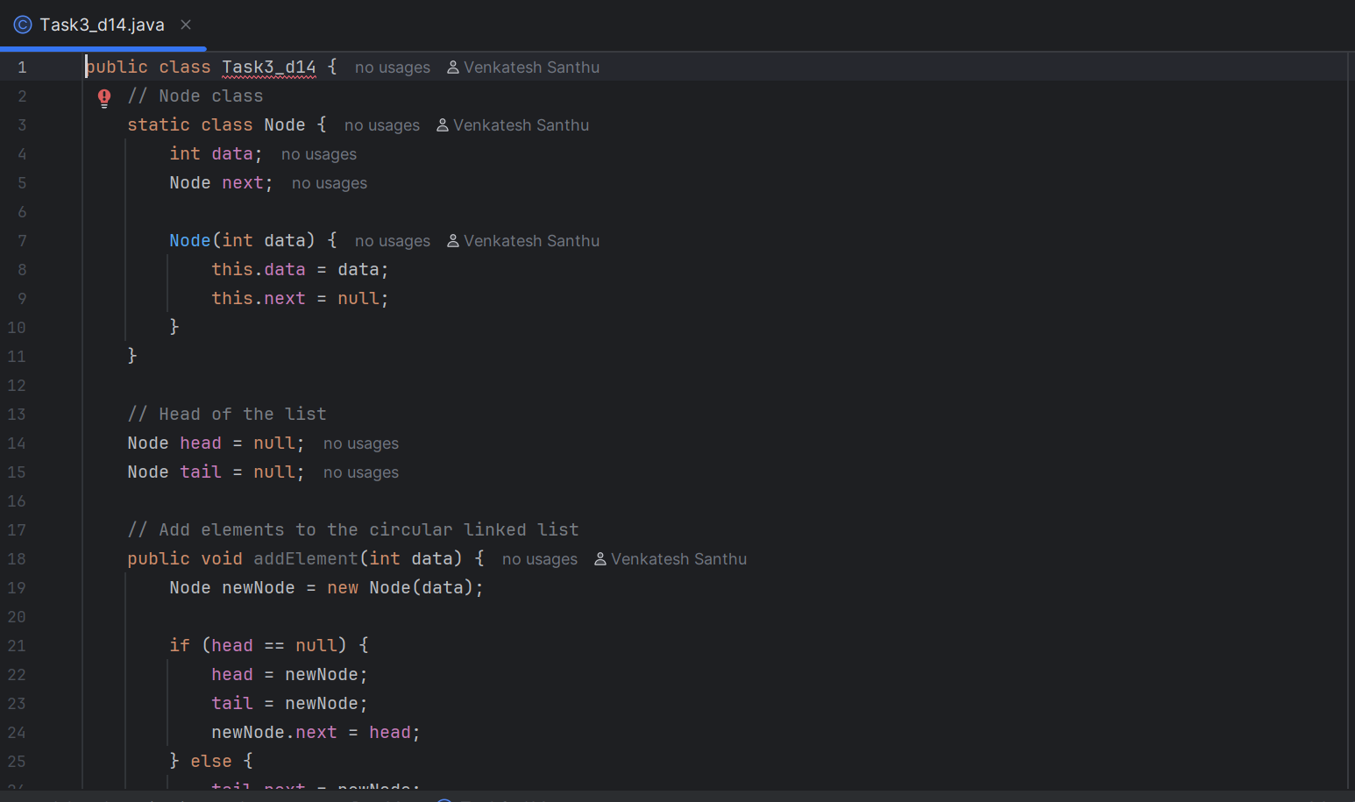

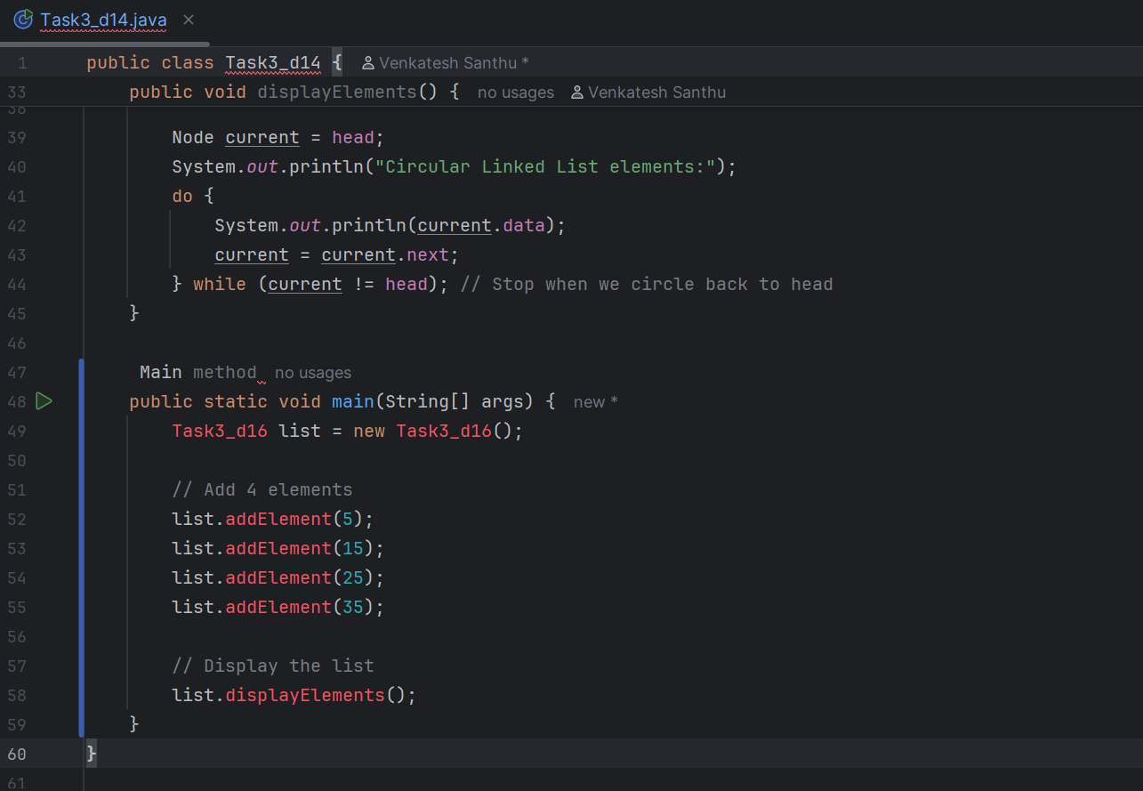

**Task 5:** Create  a  stack and pop the element also print the popped element.

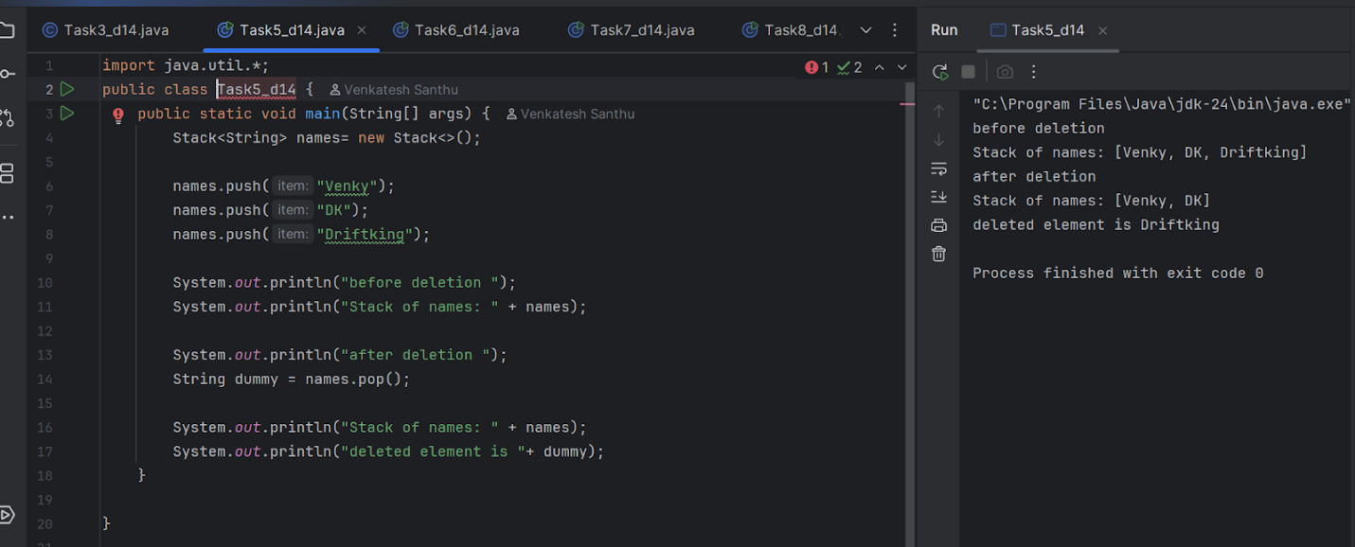

**Task 6:** Find an element in the stack and display the position

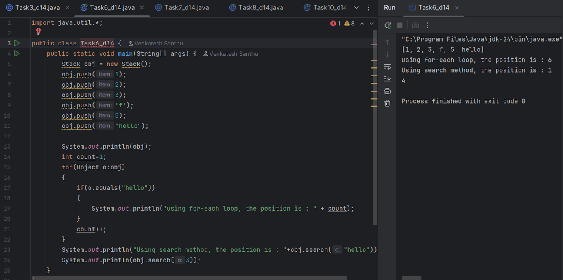

Hint 👍

Int position = names.search(“value”);

**Task 7:** Peek the element and print it ..

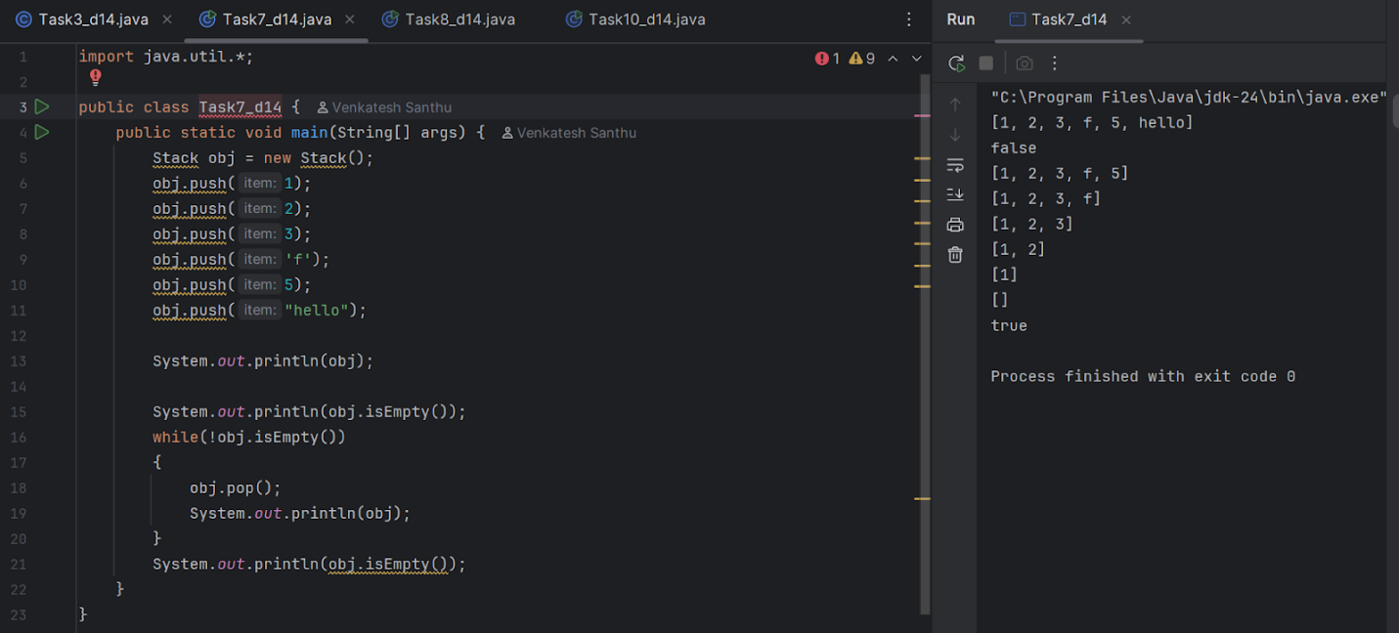

**Task 8**: Check if the stack is empty or not?

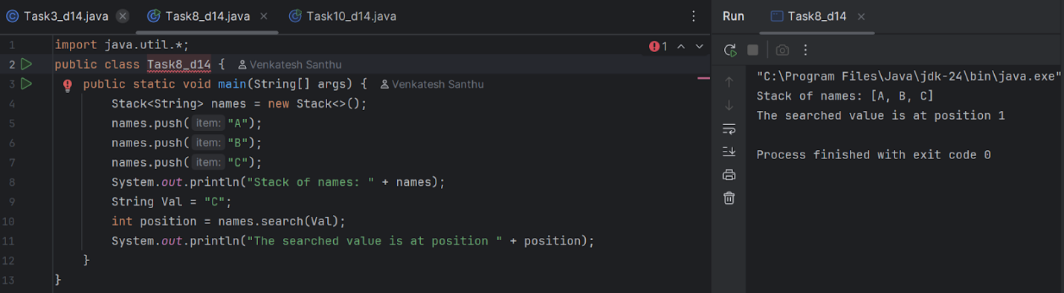

**Task 9:** What are the methods of the stack class.. List them down.. With a one liner..

The stack class provides methods for manipulating data structures. These methods are:

1. Push(): Push is used to add elements to the stack
2. Pop(): Removes and returns the elements at the top of the stack
3. peek(): Just returns the element which is at the top & doesnt remove any item
4. empty(): checks whether the stack is empty and returns true if empty
5. search(): Searches and returns the position of the element
6. size(): it gives the size or no of elements in the stack.

**Task 10**: Wap to create  a queue with custom methods

Is empty ()

Is full()

Enque

Deque

Peek

display()

